**Sinusoidal Interpretation**

**of AC Waveforms**

**Lab 10**

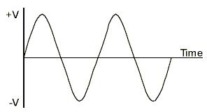

ECE 1101 Lab, Section 6

Date: Thursday, October 31st, 2019

Kyler Martinez, Daniel Tan

Equipment Used In The Experiment:

* Keysight Function/Arbitrary Waveform Generator 10Hz
  + Make/Model: 33210A
  + Serial Number: MY48017338
* Keysight InfiniiVision Digital Storage Oscilloscope 200 MHz
  + Make/Model: DSOX2022A
  + Serial Number: MY56041108

Materials Used In The Experiment:

* Breadboard
* 10 mH Inductor
* A non-polarized 10nF capacitor
* 1k Ω resistor

Objective:

Students will measure the amplitude, frequency, and phase angle from two sinusoidal waveform patterns that they generated. Then, interpret these results with sinusoidal time-domain functions.

Background Theory:

There are three cosine functions that can be used to represent different voltages. The voltage at ‘A’ is VA(t)=3Cos(2π 16000t). The lagging voltage ‘B’ is VB(t)=2.12Cos(2π 16000t+45°).



Procedure:

Before beginning the experiment, we had to construct the circuit shown in figure 1. We then placed leads at the points shown in figure one and connect them to the oscilloscope and configure the signal generator to create a sinusoidal signal with the specifications in figure 1. We then analyzed the outputs and then repeat the experiment but switching the capacitor with an inductor.

Data:

Capacitor Circuit

|  |  |  |  |  |
| --- | --- | --- | --- | --- |
| 𝜭 = -38.02o | ƒ = 15.984 kHz | Vpp = 6.1 V | Vp1 = 3.05 V | Vp2 = 2.4 V |

Inductor Circuit

|  |  |  |  |  |
| --- | --- | --- | --- | --- |
| 𝜭 = 43.64o | ƒ = 15.996 kHz | Vpp = 6 V | Vp1 = 3 V | Vp2 = 2.15 V |

Conclusion:

From our results, we can see that the capacitor circuit is lagging compared to the reference and the inductor circuit is leading compared to the reference due to the signs of their phase angles. The frequencies are relatively the same and as well as other voltages. However, the inductor’s values are most like the ideal values. This can be attributed to the fact that we used a ceramic capacitor which is known to not be accurate thus results in values that differed much from the ideal values. However, the inductors that we used have been fairly accurate to their plate values and thus resulted in values close to ideal values.

Post Lab: Lab 10

PSPICE Capacitor Simulation

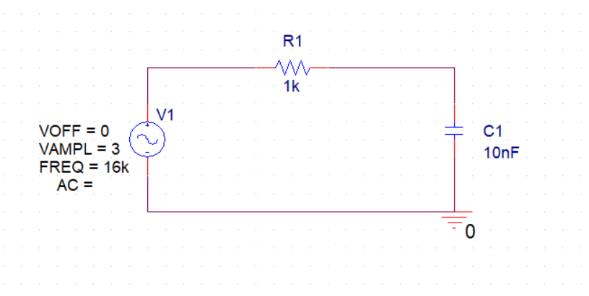

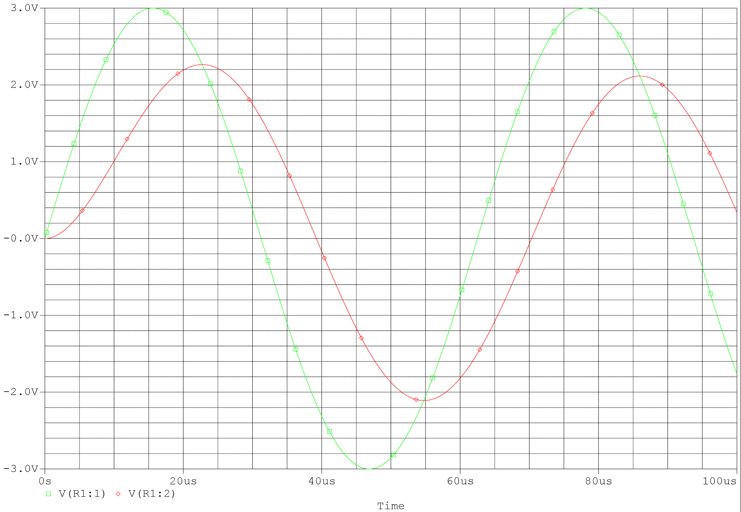

PSPICE Inductor Simulation

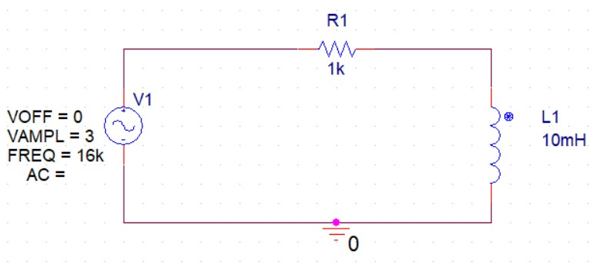

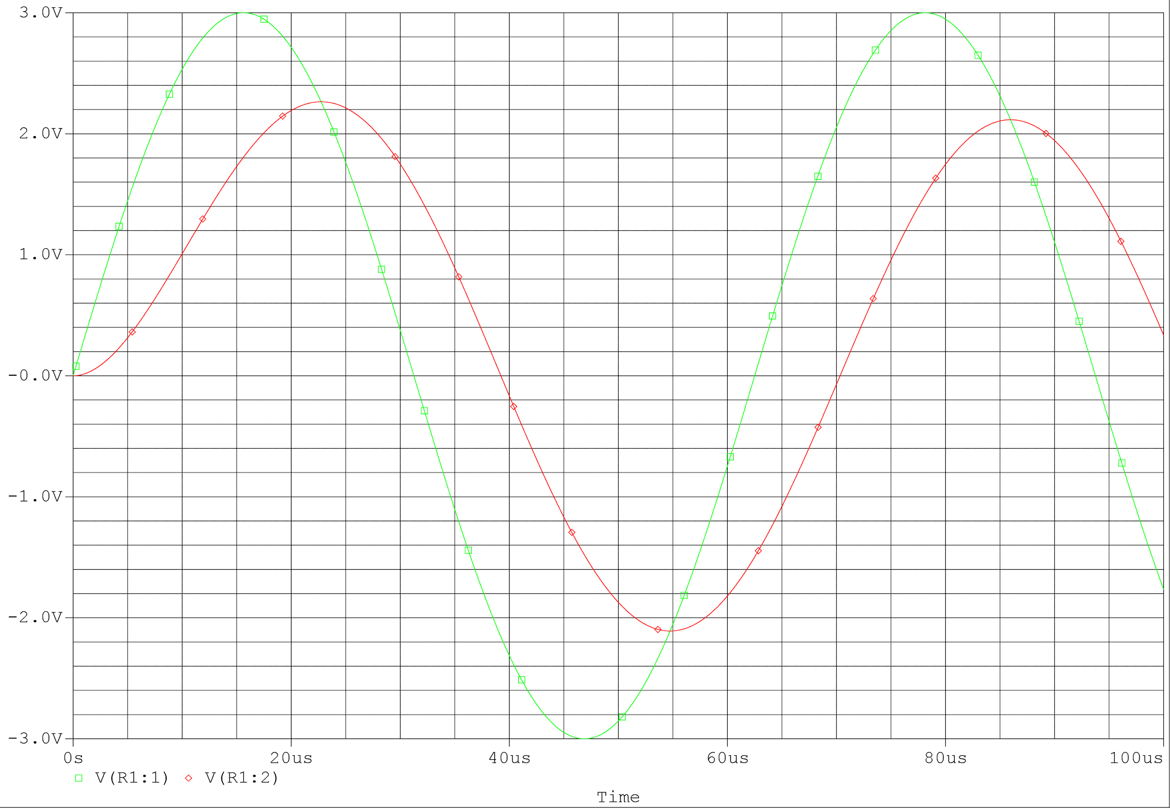

Graph Using Equations Va = 3cos(2π16*103t) and Vb = 2.12cos(2π16*103t-π/4) Capacitor Circuit

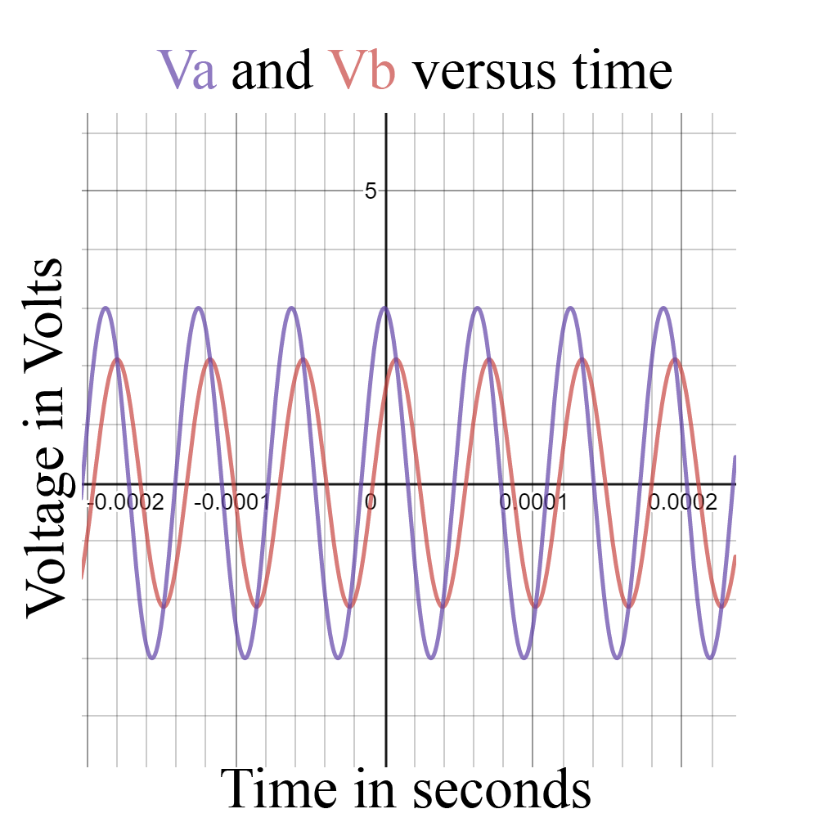

Graph Using Equations Va = 3cos(2π16*103t) and Vb = 2.12cos(2π16*103t+π/4) Inductor Circuit

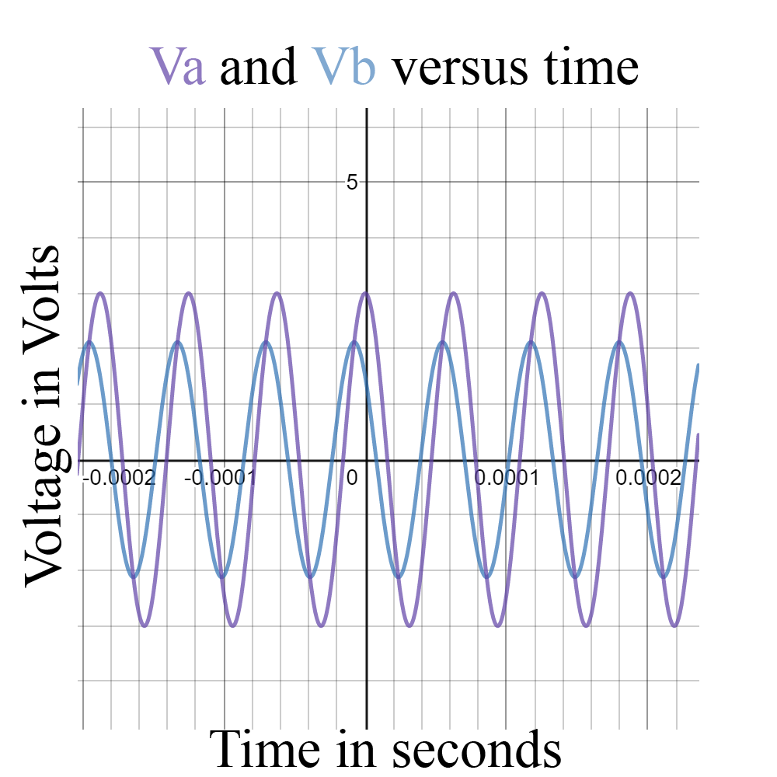

Oscilloscope Readings Capacitor Circuit

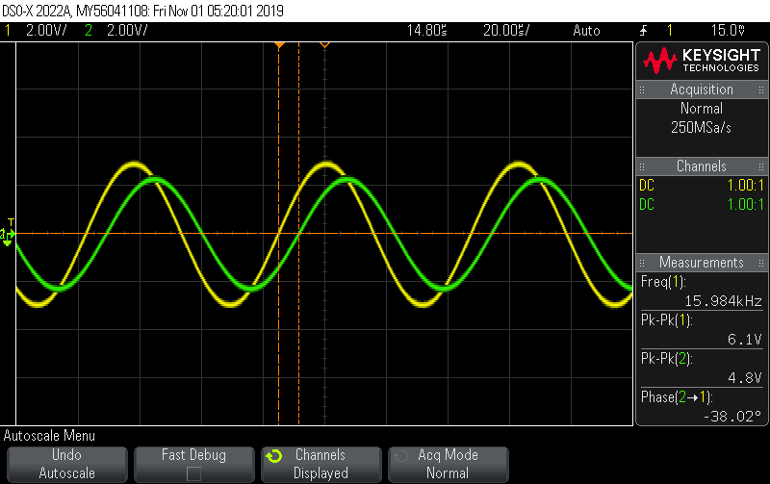Oscilloscope Reading Inductor Circuit

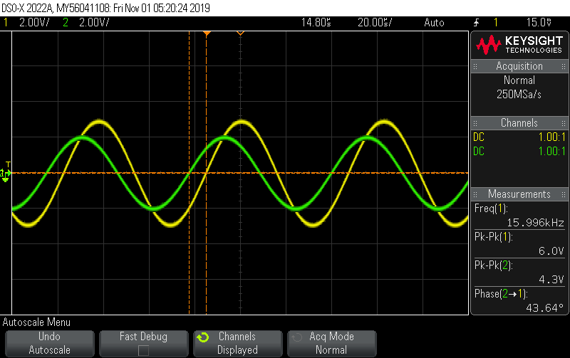

Conclusion:

Overall the graphs appear to be extremely similar in their shape along with their amplitude and phase angle. The biggest differences are with the experimental capacitor and the difference isn’t as significant with the inductor. Since the capacitor is a ceramic there is a good chance that the capacitance is far further from the plate value than expected and result in a much greater discrepancy